**TASK 1**

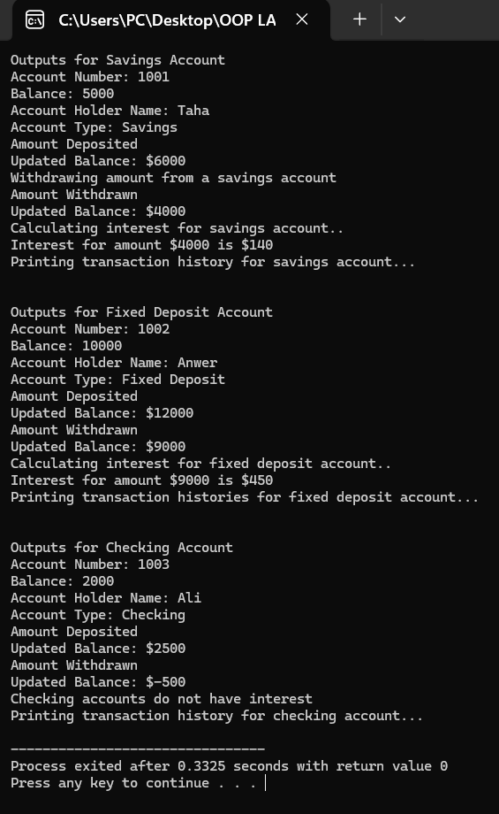

**TASK 2**

**TASK 3**

**TASK 4**

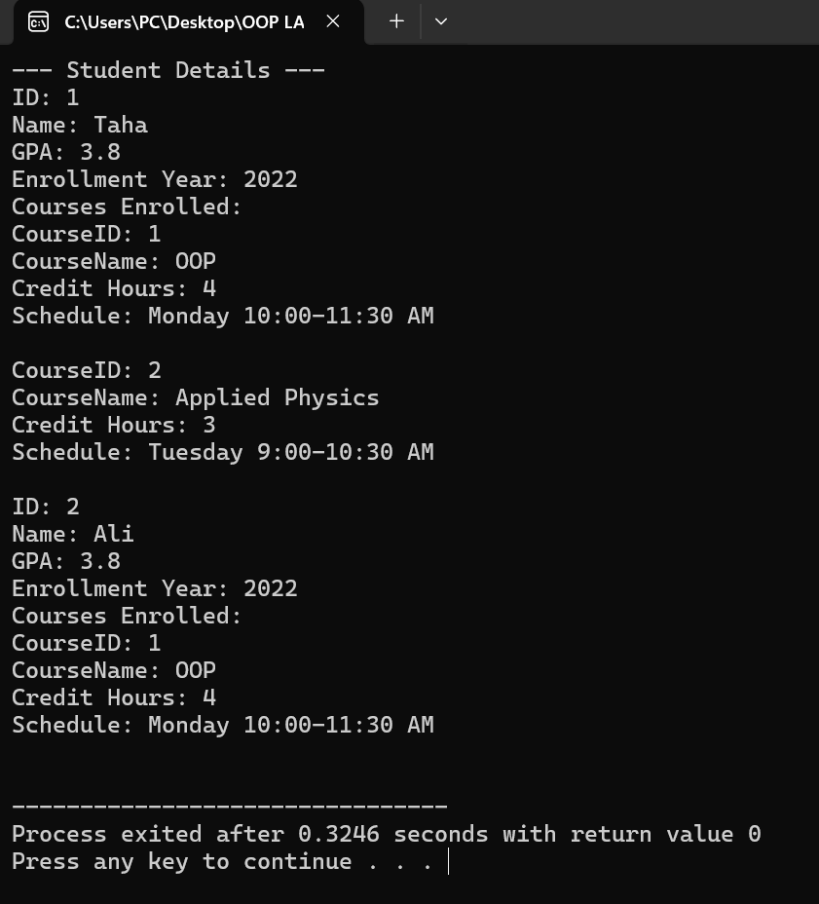

**TASK 5**

